Exploring Computer Science to Open Doors of Opportunities

Migrant Parent Conference
March 2013

Career and College Pathways in the Information and Communications Technologies (ICT) Sector

There are many types of jobs for people who have the knowledge and skill of using computers and technologies that are related to computers.

The term “Information and Communication Technologies” is used world-wide, and represents many technologies that work together.

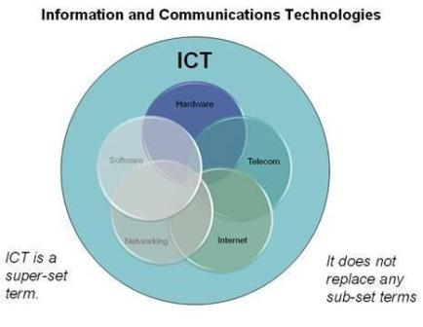
Every student needs to be digitally literate and acquire knowledge and skill about computer science and technologies in high school to become career and college ready.

The ICT Sector stands out as one of the top opportunities for students with jobs projected to increase by 27% making the ICT Sector the fastest growing career cluster through 2018. The ICT Sector meets national criteria for high demand, high wages, and high skills and is reported to be the driving force of innovation behind the efficiency initiatives of all career clusters.

The Internet has revolutionized the way consumers and businesses relate to the economy, and information technologies have driven the innovations that have revolutionized the workplace in the last quarter of a century.

The knowledge and skills students need to work in the ICT Sector will depend on whether they will simply use technologies, or enable others to use technologies; or, to invent and create new technologies.
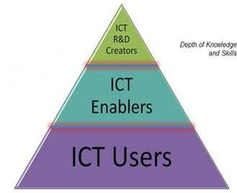

It is generally true that people with more education will be able to do more than people with less education and will earn more money.

Computer support specialists with some college/no degree earn $50,000; network and computer systems administrators with similar education earn $63,000 on average. Close to one-half of computer and information systems managers and computer software engineers obtain their Bachelor’s degree, and earn $98,000 as a result.

Workers in these categories can earn significantly more if they obtain their graduate degree, as over one-quarter do. Computer software engineers can earn $9,000 more with a Master’s degree, $94,000.

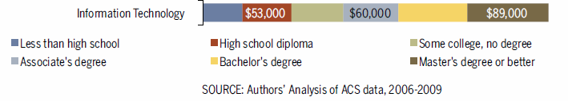

Courses like Exploring Computer Science (http://www.exploringcs.org/) help all students learn about technologies by studying subjects like computer applications and support, web design and development, networking and software and systems development. This award winning curriculum, developed in California through a partnership with the University of California at Los Angeles and the Los Angeles Unified School District, has received national recognition and is recognized by the University of California as a good course to prepare students who will attend college.

Using Technologies in Our Digital Society

The way we live in the world is changing very quickly as we become a digital society. Just as we are citizens of a physical country, so are we citizens of the digital world. As digital citizens, we need to obey the laws, and not harm anyone. Digital citizenship means the ability to use technology safely, responsibly, critically, and pro-actively to contribute to society.

Being a good citizen also means that we should be civically engaged: voting, keeping current and having our voice in political matters, and contributing to society. To this end, we need to get accurate information, and decide the verity of political messages that surround us. This same pro-active attitude and behavior also applies to the digital environment. Technology enables us to research significant social issues and to voice our opinions to a global audience.

Technologies may be used for good, or for evil. Parents can help keep their children safe by being aware of how technologies are being used by their children and by monitoring their use of technology. At schools, Teacher Librarians teach digital literacy to address the safe and proper/ethical communication and search skills necessary to be good digital citizens. Before students graduate, they need to have the digital literacy skills that are covered in the Model School Library Standards that have been adopted by the State Board of Education.

Questions and Conversations with the School Site Council and my School Principal

Does my school have classes that will prepare students for jobs in the ICT Sector?
Schools that have rigorous elective courses will help students become better prepared for careers and college.

Do the teachers at my school only teach simple skills on how to use the computer or more advanced skills like computer programming?
Because technologies change fast it is important that teachers continuously revise and improve instruction.

If only basic “how to use a computer program” skills are offered, students won’t have the knowledge and thinking skills necessary to get higher paying jobs or be prepared for college.

Does my school make sure that all students are “digitally literate”?
It is ideal that students have access to a full-time, certified Teacher Librarian and a full- time paraprofessional working as a team to ensure school-wide incorporation of appropriate use of technologies.

Teacher Librarians can work with other classroom teachers to co-design instruction to make sure students learn the digital literacy skills in the Model School Library Standards.

Are teachers at my school given training to stay current about technologies and their classroom application?
How does the school support teachers throughout their careers?

How can we get rigorous courses like Exploring Computer Science at our school?
Is the Principal satisfied that the courses that are currently taught are appropriate, rigorous and meet industry standards or is it time to adopt new courses that better meet the needs of today’s job market?

What is the process used by the school to identify, choose and adopt new courses?

Do students have access to lots of carefully selected books, databases, and other learning resources?
Available resources must reflect the school curriculum and the current educational research and recreational reading interests and needs of the students.
Do students have access to up-to-date technologies that include hardware, software, and networking that form a virtual library without walls linking students to the world of information?
Do all schools in the district have access to the same level of technology-based resources?

How do your school library eResources compare with the eResources that students in other schools in the district have?

