Information and Communication Technologies (ICT) Sector
Connected Teaching Program

Prepared by Gary Page, ICT Sector Consultant
California Department of Education

ICT Profile

The term “Information and Communication Technologies (ICT)” is an umbrella term that encompasses all rapidly emerging, evolving and converging computer, software, networking, telecommunications, Internet, programming and information systems technologies. The ICT Sector stands out as one of the top opportunities for students with jobs projected to increase by 27% making the ICT Sector the fastest growing career cluster through 2018. The ICT Sector meets national criteria for high demand, high wages, and high skills and is reported to be the driving force of innovation behind the efficiency initiatives of all career clusters.

The ICT Sector represents a mix of three industry clusters:

- Hardware – firms that create, manufacture and distribute computer, peripheral, networking and related equipment.
- Software – firms that create, manufacture and distribute computer operating systems and applications.
- Services – firms that bundle hardware, software and other services to deliver solutions to business and consumer customers.

Quick facts about California’s ICT Industries:

- There are about 46,000 ICT Industry related businesses (1 in 28 companies) in California.
- They produce about $172 billion in revenue (6% of total California private sector revenues).
- They employ more than a million California workers (1 in 17 private sector jobs).
- They pay about $76 billion in wages (12 % of private sector wages, the 2nd highest wage sector) in California.
- The median ICT Workforce hourly wage is about 60% higher than the median wage of all jobs.

ICT as an Innovative Driving Force

The Internet has revolutionized the way consumers and businesses relate to the economy, and information technologies have driven the innovations that have revolutionized the workplace in the last quarter of a century. In the 19th and 20th centuries, electricity and the internal combustion engine drove the rise of manufacturing and America’s shift away from an agrarian economy. Today, computers and related inventions are driving the information revolution, transforming the U.S. economic landscape once again. Just as building a mass K-12 education system was essential for producing workers capable of carrying out the industrial revolution, the information revolution is demanding the building of a mass postsecondary system to meet the needs of sophisticated new and rapidly changing industries, such as computer systems design or financial services.

Information technologies have managed to touch nearly every aspect of life. For example, initiatives in Health Science seek to improve coordination of care with electronic health records. ICT professionals design the protocol for these records and ensure their security and usability. The global spread of mobile phones provides evolving opportunities for workers to link service providers to consumers in new markets. This career cluster continues to revolutionize finance and banking, allowing for easier exchange and changing the way people purchase and consume goods.

Not only has technology changed the way people consume, it has also dramatically changed the workplace. New computer programs have increased efficiency and productivity in nearly all industries: engineers in manufacturing can design and test new products in a fraction of the time previously required and instantly program their designs into automated assembly lines, thus keeping production up to date with market trends.

The ICT Sector has shaped, and continues to shape, in countless ways staffing and employment patterns favoring more skilled workers. Two competing trends will decrease and increase the demand for skills during the next decade. On the one hand, information technology jobs that require limited technical skill, local knowledge, or innovation are liable to be outsourced overseas because computer programming is not place-specific and transportation costs are close to zero. However, the impending retirement of baby boomers guarantees a significant amount of job openings, at least temporarily, for qualified workers. Close to 40 percent of workers were between 45 and 63 years of age in 2009. Career opportunities will be best for workers with experience in information protection and security, as sensitive information (bank records, health records, and corporate and national secrets) increasingly shifts online and needs to be protected.

Challenges and Opportunities

According to data gathered from the National Center for Women in Information Technology, California will have an average of more than 20,000 computing job openings each year for the next five years. Filling these openings requires an educated and qualified workforce. Such a workforce will not exist unless California’s K-12 students are given engaging, meaningful, and adequate exposure to ICT Sector courses at their schools and beyond as these are the critical years for shaping inclinations and decisions for career paths.

According to data from the Workforce Development Division of the American College Testing Program, Inc., now known as “ACT”, a “Preparation Gap” can exist when the study choices of students are not aligned with the requirements of industry. Based on information provided by ACT-tested graduates, 2010, student career interests did not coincide with industry demand in the Computer/Information Specialties. While 11% of the projected annual job openings are in the ICT Sector, only 2% of the students have knowledge and skills aligned with the requirements of industry.

Instruction “about computers” in K-12 has been evolving as this subject is relatively new and continues to rapidly evolve. According to a report entitled In Need of Repair: The State of K-12 Computer Science Education in California: “… the current state of K-12 computer science education in California and the structures that impact its future viability are a troubling, confusing, and patchwork arrangement requiring serious reform.” The major segments requiring reform include:

- The courses students have the opportunity to take with their varying levels of usefulness, engagement and credit;
- The teachers who have the credentials and the needed computing skills and knowledge; and,
- The professional development and material resources needed to teach effectively.

According to the Multiple Pathways to Student Success report: “… there appears to be a growing consensus that: California is not succeeding in preparing students for ongoing education and employment in the twenty-first century.” Amid extensive ongoing discussion in state policy forums, there continues to be persistent pressure for the state to lead efforts to improve graduation rates, close achievement and opportunity gaps, and prepare all students for success in pursuing both “living-wage” careers and a variety of postsecondary learning experiences.

An excellent and award winning “foundational” course for the ICT Sector called “Exploring Computer Science (ECS)” was recently developed in California through a partnership with the University of California Los Angeles (UCLA) and the Los Angeles Unified School District. ECS is a year-long course, consisting of six units. ECS is designed to introduce students to the foundational, creative, collaborative, interdisciplinary, and problem-solving nature of computer science. ECS prepares students for college and careers by learning 21st Century skills. The ECS course provides engaging activities to foster project and team collaboration, and has the rigor to prepare students for advanced placement computer science instruction. This course has received both “g” credit standing from the University of California Office of the President and approved for Career Technical Education (CTE).

Schools in California now have an opportunity to offer a wider range of courses, including those in the ICT Sector. Recent changes to California Education Code Section 51225.3 now allow California schools offering instruction in any of grades nine to twelve, inclusive, to give students an option to enroll in a CTE course as an alternative to the graduation requirement in visual or performing arts or foreign language beginning with the 2012–13 school year (class of 2013). Under previous California law, all pupils receiving a diploma of graduation from high school must complete one course in visual or performing arts or foreign language.

Teaching today is often practiced in isolation. Many CTE educators work alone, with little interaction with professional colleagues or experts in the outside world. Professional development typically is provided in short, fragmented, and episodic workshops that offer little opportunity to integrate learning into practice. A classroom educator’s primary job is understood to be covering the assigned content and ensuring that students test well. Many educators do not have the information, the time, or the incentives to continuously improve their professional practice from year to year.

The California Department of Education recognized the urgent need to connect educators with one another to enable them to collaborate and think more critically about their practice and to provide them effective tools as they attempt to close the achievement gap and raise overall student achievement across our large and diverse state. Working with the K-12 High Speed Network (K12HSN), the CDE has established the Brokers of Expertise (BoE) initiative to embrace technology and provide effective tools and resources to schools and districts as they strive to reach ambitious goals for student achievement. The BoE project will accomplish this by offering online resources that:

- Provide classroom tools and resources that are aligned to California Content Standards
- Provide resources that are searchable by grade, content level and demographic information
- Provide opportunities for creating and publishing high-quality content that has proven effective for teachers
- Facilitate communication and dialogue with educators across the state who have similar questions

The Center for the Advancement of Digital Resources in Education (CADRE) provides curriculum development support through CTE Online and also supports teachers through the development and support of the Brokers of Expertise website. Teachers may access content house on CTE Online via the Brokers of Expertise website.

UCOP Program Status

The University of California Office of the President (UCOP) has established requirements to ensure that students who enroll at the University can participate fully in the first-year college programs. Students who complete a UCOP prescribed “a-g” pattern of study demonstrate they have attained essential critical thinking and study skills and assure the faculty that the student has attained a body of general knowledge that will provide breadth and perspective to new, more advanced study. School district governing boards throughout California often require the UC course “a-g approval” before adopting a course to be taught at the school site. The UCOP permits organizations that meet certain requirements to receive “program status” that allows for Districts to adopt a “a-g” approved course without applying for the status directly.

The ICT Sector needs to apply for and receive “program status” in order to accelerate the adoption of model ICT courses to address the preparation gap and to provide students with the knowledge and skills required by employers. Key model pathway courses need to be identified and further developed so that the course has both the rigor of a college preparatory course (a-g credit) and the relevance of a career-focused (CTE) course.

ICT Connected Teaching Program

To qualify for UCOP program status, the ICT Sector needs to define and establish a “program” that meets UCOP requirements. The intent of the ICT Connected Teaching Program is to obtain the UCOP program status for key pathway courses that have a-g status, and then provide resources and support to classroom teachers to strengthen instruction to enable students to attain knowledge, skills, abilities, and personal resources to successfully achieve their career and college goals. The collaboration in this program is based on the four elements of trust: consistency, compassion, communication and competence.

Program components include model curriculum aligned to the ICT Sector career pathways, rigorous academic and career technical education, with a career focus, a committed network of teachers and schools, and active business and post-secondary partnerships. A Professional Learning Community will be established for each course on the ICT Program list, and teachers will work together and across disciplines to provide reciprocal support and to identify and refine effective practices. Teachers collaborate through professional development network activities, implement program courses with fidelity, and use common assessments to improve student learning.

The mission of the California Department of Education is to provide a world-class education for all students, from early childhood to adulthood. The Department of Education serves our state by innovating and collaborating with educators, schools, parents, and community partners. Together, as a team, we prepare students to live, work, and thrive in a highly connected world.

ICT Program Objectives

Increase local adoption of rigorous CTE courses related to the ICT Sector.

Obtain a-g ICT Sector “program status” to list excellent ICT pathway courses so that standardized courses with high rigor can easily be adopted by school districts.

Establish “program membership” process and implement appropriate support structures to meet and exceed UC program status requirements.

Organize program members around each pathway course to reduce isolation and to link teachers of similar courses to promote collaboration and sharing of best practices. This collaboration will promote common assessments and essential understanding of content based on the Backward Design Process.

Organize course web page portals consisting of general course description, syllabus, course content, lesson plans, student competencies and skill requirements (performance standards), outcome measurement methods.

Annual cycle of regular course support and lesson plan improvement - Plan, Implement, Assess, Revise:

A “program course” is associated with a series of lesson plan pages that are developed to provide lesson plans and links to activities for teacher to use to implement the curriculum.

The lesson plan pages may include a video of a mentor teacher to present an overview of the lesson, and strategies that may be considered to adjust the lesson for individual students.

During their prep period, teachers who are “program members” access the lesson plan page to receive the daily lesson plans and activities. On the course web page there are links to student activities, resources and assessments. Some teachers may choose to review the daily plans for the week, and then adjust their daily instruction as appropriate to their students.

Teachers who wish to collaborate, will be able to provide feedback, through a comment section, on how well the lesson plan and activities “worked” for them, how they would change the plan for next year, and what other resources could be used to improve instruction.

The program would establish an advisory group from the program members who teach the course to consider the feedback received from teachers and take steps to revise the curriculum by revising the daily plan for the next teaching cycle. The course web page would be updated accordingly, and be ready for the next school year.

Peer Coaching

All teachers who are assigned to teach a course from the ICT Connected Teacher Program may also benefit from peer coaching to ensure the course is effectively implemented with fidelity. Peer coaching is provided by teacher mentors, who provide ongoing support to teachers by modeling, coaching, collaboration, and problem solving.

The strength of peer coaching lies in its potential to promote a culture of collaboration and professionalism among teachers. It is also designed to improve the level of implementation of new instructional techniques and curriculum. Research demonstrates that peer coaching programs encourage professional growth, recognition, experience-enhancing roles, and collegiality for teacher mentors (Killion, 1990).

Peer coaching is provided to:
- establish a culture of standards and expectations;
- improve instructional capacity;
- support a process of ongoing evaluation through common assessments; and,
- to connect classroom practices to a policy context.

Peer coaching will seek to improve existing teacher practices by refining techniques, developing collegiality, increasing professional dialogue, and assisting teachers to reflect on their teaching.

Teacher mentors:

- Establish a coaching culture that values collegial interaction and professionalism among participants;
- Advise about instructional content and strategies;
- Share new ideas on curriculum and instruction;
- Focus on linking new information to existing knowledge, experience, and values;
- Provide support and companionship;
- Consult about lesson plans and objectives;
- Encourage reflection on the teaching and learning process;
- Focus on the components of planning and developing curriculum and instruction; and,
- Lead teachers in collaborative planning and development of lesson plans.

Conceptual “Mind Map” of teacher/course support

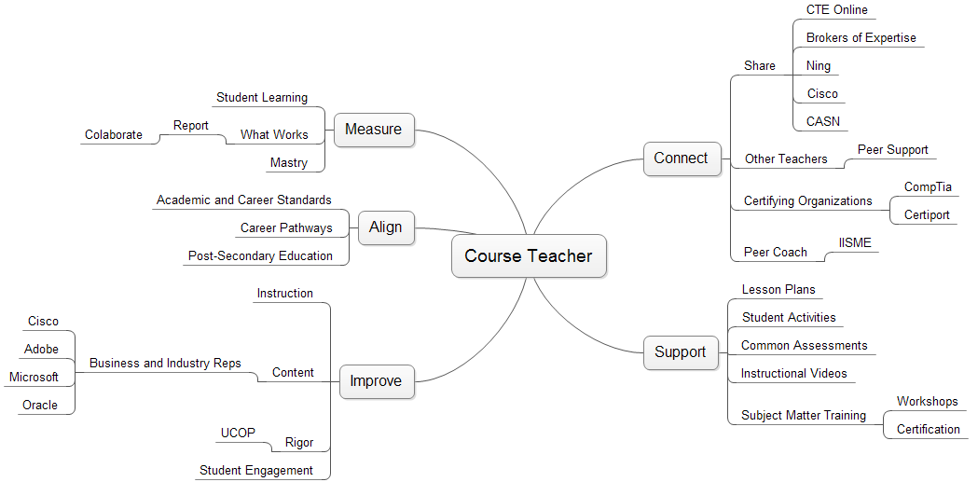

This report was developed for the California Computing Education Advocacy Network (CCEAN), with support from the Computer Science Teachers Association, Funded by National Science Award CNS-1044540.
This report was developed for the California Department of Education, with support by the Carl D. Perkins Career and Technical Education Improvement Act of 2006 grant funds, by a grant from the James Irvine Foundation, and by the California Department of Education.
Vodicka, D. (November 2006). “The Four Elements of Trust: Consistency, Compassion, Communication, and Competency.”
Adapted from Understanding by Design (UbD) by Grant Wiggins and Jay McTighe

