Increasing Our Focus on Soft Skills
A Proposal to California FBLA (CAFBLA) Leadership
By Gary Page, CDE Representative to CAFBLA

May 2017

Essential Skills for the 21st Century
Burning Glass Technologies recently issued a report entitled THE HUMAN FACTOR which highlighted the importance and lack of “soft skills” in job applicants. Based on an analysis of millions of job postings, across the United States, “baseline skills” are in high demand by employers.
According to the report:
A fundamental question in the modern, increasingly automated job market surrounds the importance of foundational or “soft skills.” Human interaction has proven decidedly difficult to computerize, and many economists believe the labor market is placing increasing value on social and other non-technical skills. Recent studies from Harvard and Stanford have found that jobs with high social skill requirements have experienced greater wage growth than others. In addition, employment and wage growth has been strongest in occupations which require both strong social skills and high level of cognitive skills.
Developing Highly Effective People in Schools
Current leadership practices and the development of soft skills (or social and emotional skills) have been successfully addressed in a number of schools. For example, the importance of soft skills is emphasized in the writings of Dr. Steven R. Covey, author of the book The 7 Habits of Highly Effective People. In an effort to turn around her failing school, Muriel Summers, Principal of A.B. Combs Leadership Magnet Elementary School in Raleigh, N.C., identified leadership as her school magnet theme based on community feedback. She approached FranklinCovey as a partner in designing, developing and implementing a leadership model for her school, which drew on The 7 Habits and also incorporated Baldridge quality tools and other educational best practices.
Within a few years, A.B. Combs experienced what they viewed as a complete turnaround, ultimately being named #1 Magnet School in the U.S., twice. In response to the success achieved by Muriel Summers and her teachers, FranklinCovey developed and initiated The Leader In Me program for elementary and middle schools.
Soft skills, like those being taught through The Leader in Me program, focus on the following “leadership” skills:
- Leadership
- Responsibility
- Accountability
- Problem Solving
- Adaptability
- Communication
- Initiative and Self-Direction
- Creativity
- Cross-Cultural Skills
- Teamwork

Building Capacity of CAFBLA Advisers through Alignment with the 7 Habits

Business teachers in California may incorporate soft skill instruction in a number of ways. The Career Technical Education Model Curriculum (CTE) standards include the Standards for Career Ready practice and Industry Sector “anchor standards” which identify the kinds of skills students should develop. CDE also offers lesson plans designed to introduce students to a broad range of critical career readiness knowledge and skills, leading to the development of a personal career action plan.
Beyond what is available through CDE, Covey’s 7 Habits and The Leader in Me program offer resources that have been developed by, and tested through teacher collaboration for many years. Since its official launch in 2009, over 3,000 public, private, charter and magnet schools across 50 countries have adopted The Leader in Me process.
Clusters of schools that have adopted The Leader in Me can be found in California.
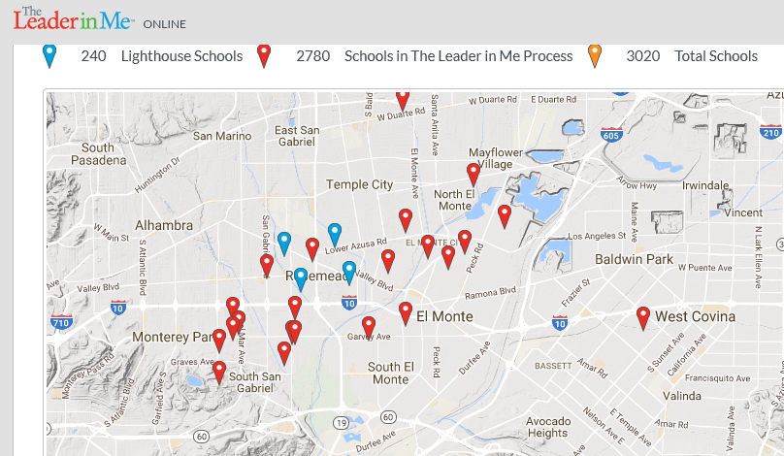

The above map shows clusters of The Leader in Me schools in the El Monte area. Similar clusters are found in the Bay and Sacramento areas.
Moving Forward on Leadership Initiatives
CDE is working with CAFBLA to build the capacity of Advisers to teach soft skills to CAFBLA students through professional development and with Leadership Development Institute (LDI) support, within the framework of 7 Habits. CDE is providing funds to train 20 CAFBLA Advisers in Northern California and 20 CAFLB Advisers in Southern California to become certified trainers of the 7 Habits content. Three days of training will focus on the 7 Habits of Effective People and how to teach those habits to teenagers.
Next Steps?
To better prepare all CAFBLA students for college and careers, the CDE requests that CAFBLA increase its focus on helping all students acquire leadership skills that are in high demand by employers. The focus would be a leadership initiative within California that expands the services CAFBLA currently provides and would:
- Focus on soft skill (leadership) such as those found in the 7 Habits framework;
- Work to align The Leader in Me schools with CAFBLA Chapters; and
- Establish a Teacher Leadership Network of interested CAFBLA Advisers.
Each of the six CAFBLA Sections would be responsible for the leadership and development of the expanded program within their Section. Six new CAFBLA Section co-directors would be recruited to head up the leadership initiative in each Section. The new co-directors would be comprised of Advisers that are not currently involved with the operation of the CAFBLA competitive events program.
- CDE and FrankinCovey will collaborate with Section leadership to find and provide resources to support leadership initiatives that are decided upon by Section leadership.
- Leadership Initiatives may include, for example:
- Developing and enhancing leadership pathways from elementary school to high school.
- Increasing middle school CAFBLA Chapters at school where there is a high number of at-risk students.
- Conducting Leadership rallies that inspire students to do their best at high school.
- Implementing Leadership Camps during the summer at the school site or away from the school site.
- Implementing Leadership Camps designed specifically for English Learners.
- Implementing Leadership Camps designed specifically for students from families with low and very modest incomes.
- Implementing “Gap-Year” Global Leadership programs that include foreign students.

“The Growing Importance of Social Skills in the Labor Market,” Deming, D, NBER Working Paper, 2015, www.nber.org/papers/w21473
“The Payoff to Skill in the Third Industrial Revolution,” Liu, Y, and Grusky, D. American Journal of Sociology, 2013, www.jstor.org/stable/10.1086/669498

